**Windows**

Step 1: Download the latest Geth Windows release from Geth’s GitHub page.

The link to the Github page is as follows: <https://ethereum.github.io/go-ethereum/downloads/>

Step 2: Select below version and install Geth.

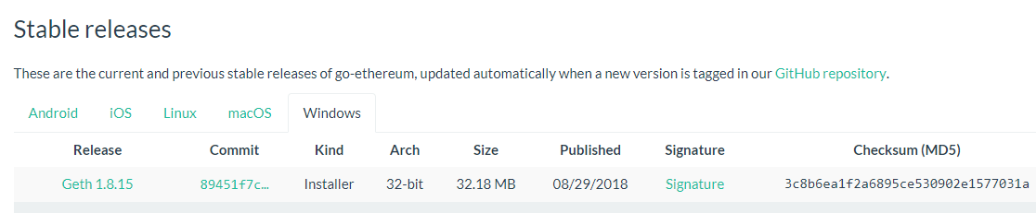

Step 3: Open “Windows PowerShell”

Step 4 : Run “mkdir -p Chainskills/private” to create directory structure

Step 5: Follow common steps for Windows and Linux

**Linux**

Step 1 : mkdir -p Chainskills/private to create directory structure

Step 2 : Install Geth

1. So first of all we need to install the software properties using the following command.

*sudo apt install software-properties-common*

1. After that we need to add the Ethereum repository as follows.

*sudo add-apt-repository -y ppa:ethereum/ethereum*

1. Update the repositories.

*sudo apt update*

1. install the Ethereum.

*sudo apt install ethereum*

1. Check for successful installation

*geth version*

**Common Steps for Windows and Linux**

Step 1: Setup Jason Node using Puppeth utility

Please specify a network name to administer (no spaces, please)

> Chainskills

What would you like to do? (default = stats)

1. Show network stats

2. Configure new genesis

3. Track new remote server

4. Deploy network components

> 2

Which consensus engine to use? (default = clique)

1. Ethash - proof-of-work

2. Clique - proof-of-authority

> 1

How many seconds should blocks take? (default = 15)

> 10

Which accounts should be pre-funded? (advisable at least one)

> 0

Anything fun to embed into the genesis block? (max 32 bytes)

> <ENTER>

What would you like to do? (default = stats)

1. Show network stats

2. Save existing genesis

3. Track new remote server

4. Deploy network components

> 2

Which file to save the genesis into? (default = Chainskills.json)

> <ENTER>

What would you like to do? (default = stats)

1. Show network stats

2. Save existing genesis

3. Track new remote server

4. Deploy network components

> <CTRL-C>

Step 2 : Open Genesis File and check contents

Step3 : Create Private node in initializing Genesis block

*Geth –datadir . init Chainskills.json*

GETH Directory is for storing the Chaindata or Blockchain Nodes

Keystore is to keep accounts

Step 4: Create multiple accounts using -

*Geth –datadir . account new*

Step 5: View account list using -

*Geth –datadir . account list*

Step 5: Run startnode.sh or Startnode.bat

*geth --networkid 4224 --mine --minerthreads 2 --datadir "." --nodiscover --rpc --rpcport "8545" --port "30303" --rpccorsdomain "*" --nat "any" --rpcapi eth,web3,personal,net --unlock 0 --password ./password.sec*

Chmod _x startnode.sh

*./startnode.sh*

This will start the Blockchain network.

Step 6: Attach the Geth console using -

*Geth attach*

Step 7: Run Geth Commands for viewing or managing transactions

*Eth.accounts – Check Existing accoints*

*Eth.coinbase – View Coinbase account or miner*

*Eth.getbalance(eth.coinbase) – Get the balance from Coinbase accoint*

*Eth.getbalance(eth.accounts[1]) – Get balance from any other accounbt*

*Miner.stop() – Stop Mining Operation*

*Miner.start(1) – Start mining operation with 1 thread*

*Net.version – Network version*

*Personal.unlockaccount(eth.accounts[1]) – Unlock account to initiate transaction*

*Eth.sendtransaction({from: eth.coinbase, to: eth.accounts[1], value: web3.towei(10, “ether”)}) – Transfer ether from one account to another*

Detailed Command list and description:

*https://github.com/ethereum/go-ethereum/wiki/Command-Line-Options*